**Assignment 8**

**Name: Mudit Mohit**

**Enrolment No.: BT21GCS057**

**Section: B2**

**Question:** Explore the correctness and efficiency of Strassen's matrix multiplication algorithm. Compare its performance with simple matrix multiplication in terms of best, average, and worst-case complexity.

Ans.

**def strassen_matrix_multiply(A, B):**

**n = len(A)**

**if n == 1:**

**return [[A[0][0] * B[0][0]]]**

**mid = n // 2**

**A11, A12, A21, A22 = A[:mid], A[mid:], A[:mid], A[mid:]**

**B11, B12, B21, B22 = B[:mid], B[mid:], B[:mid], B[mid:]**

**m1 = strassen_matrix_multiply(A11, sub_matrix(B12, B22))**

**m2 = strassen_matrix_multiply(add_matrix(A11, B12), B22)**

**m3 = strassen_matrix_multiply(add_matrix(A21, A22), B11)**

**m4 = strassen_matrix_multiply(A22, sub_matrix(B21, B11))**

**m5 = strassen_matrix_multiply(add_matrix(A11, A22), add_matrix(B11, B22))**

**m6 = strassen_matrix_multiply(sub_matrix(A12, A22), add_matrix(B21, B22))**

**m7 = strassen_matrix_multiply(sub_matrix(A11, A21), add_matrix(B11, B12))**

**k11 = add_matrix(sub_matrix(add_matrix(m5, m4), m2), m6)**

**k12 = add_matrix(m1, m2)**

**k21 = add_matrix(m3, m4)**

**k22 = add_matrix(sub_matrix(sub_matrix(add_matrix(m5, m1), m3), m7), m2)**

**result = [[0] * n for _ in range(n)]**

**for i in range(mid):**

**for j in range(mid):**

**result[i][j] = k11[i][j]**

**result[i][j + mid] = k12[i][j]**

**result[i + mid][j] = k21[i][j]**

**result[i + mid][j + mid] = k22[i][j]**

**return result**

**def add_matrix(A, B):**

**n = len(A)**

**return [[A[i][j] + B[i][j] for j in range(n)] for i in range(n)]**

**def sub_matrix(A, B):**

**n = len(A)**

**return [[A[i][j] - B[i][j] for j in range(n)] for i in range(n)]**

**A = [[2, 3, 3, 4], [7, 7, 11, 10], [10, 1, 2, 3], [2, 2, 7, 10]]**

**B = [[4, 9, 6, 2], [2, 6, 6, 7], [8, 3, 4, 11], [1, 3, 1, 5]]**

**C = strassen_matrix_multiply(A,B)**

**print(C)**

**Output:**

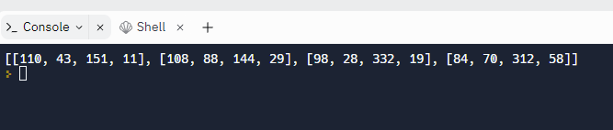

**Time complexity of Strassen matrix multiplication: O(n^log7) = O(n^2.8074)**

**Time complexity of General method of Matrix Multiplication: O(n^3)**